Class Participation Bonus 1
Student Name: ARNAV KUCHERIYA
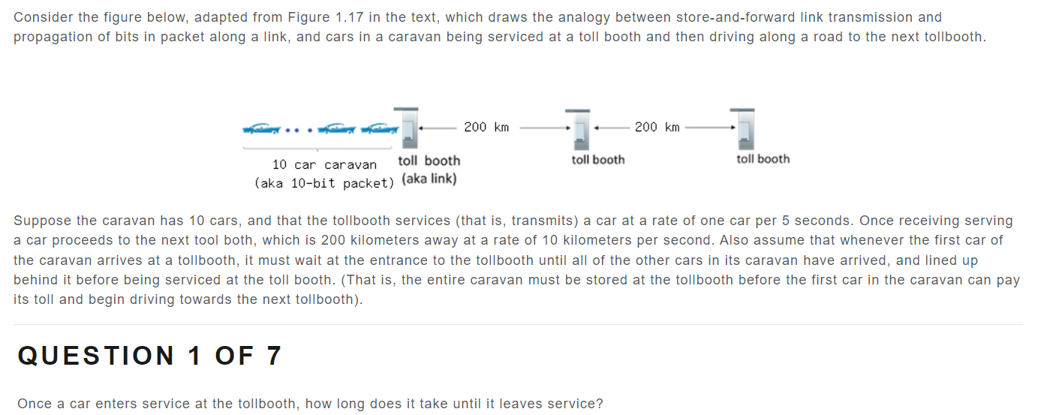

Answer: 5 seconds


Answer: 50 seconds

Answer: 20 seconds



Answer:20 seconds

Answer: 65 sEconds


Answer: No


Answer: Yes (t=50s to t=70s)

